Operational Concept Description (OCD)

Improving Thai CDC
Establishing a New Client/Donor/Partner Communications
&
Project Tracking Tool Development

Team #:01

Team Members and roles:
Name | Primary/Secondary Role
Brandon Foster | IIV & V, Requirements Management, System Engineer & Quality Management, Implementation Team Member
Charles Muckenthaler | IIV & V and Requirements Management and System Engineer & Quality Management
Ding Li | Life Cycle Planner/Software Architect
Yi Li | Feasibility Analyst, Tester, and Requirements Engineer
Ino Mantaring | Prototyper, Builder, and Requirements Engineer
Vishal Punjabi | Operational Concept Engineer, Implementation Team Member, and Prototyper
Katelyn Swift-Spong | Project Manager, Implementation Team Member, and Operational Concept Engineer

12/05/2011

Version History
Date | Author | Version | Changes made | Rationale
09/28/2011 | VP | 1.0 | - Initial OCD | - Creating Operational Concept Definition (OPD)
10/07/2011 | VP | 1.1 | - [Bug 4635] New: Inconsistent Team Number Convention  - [Bug 4643] New: Date is in the wrong format  - [Bug 4644] New: The formatting of the version is inconsistent with the SFA  - [Bug 4645] New: Missing Detail  - [Bug 4646] New: Inconsistent Footer  - [Bug 4647] New: Inconsistency with numbering convention  - [Bug 4648] New: Inconsistent Date Format  - [Bug 4649] New: Enhancement to Figure name  - [Bug 4650] New: Grammar correction  - [Bug 4651] New: Grammar correction  - [Bug 4652] New: Ambiguous Identificaiton of Stakeholders  - [Bug 4654] New: Missing Important Details  - [Bug 4654] Missing Important Details  - [Bug 4656] New: Missing all of the benefits from the Winbook Tool  - [Bug 4658] New: Missing Benefits from WInbook Tool  - [Bug 4657] New: Incorrect Grammar  - [Bug 4659] New: Incorrect Grammar  - [Bug 4660] New: Inconsistent format  - [Bug 4661] New: Inconsistent format | - Changed from Team:#1 to Team#:01 for clarity  - Changed date on title page from mm/dd/yy to mm/dd/yyyy for clarity  - Changed from Version:#.# to Version No.:#.# in header for clarity  - Removed extension from document name in footer for correctness  - Changed date in footer from mm/dd/yy to mm/dd/yyyy for clarity  - Changed page number in footer from upper case roman numeral to lowercase for consistency with other VC package documents  - Changed date in version history table from mm/dd/yy to mm/dd/yyyy for consistency  - Added the word “current” to the name of figure 3 and figure 4 for clarity  - Capitalized the word “usc” for correctness  - Purpose of OCD updated to include the reasoning for the use of NDI process  - Explicitly stated the names of Thai CDC representatives for preciousness  - Updated system capability description from a bulleted point list to a paragraph style for clarity  - Added for detail to system capability description for better understanding  - Added more benefits because they are critical for the success of the project  - Updated the benefits chain diagram to include all the benefits  - Fixed grammatical errors in benefits chain section for clarity  - Fixed grammatical errors in information on current system section for clarity  - Removed table from artifacts section and instead used bullet points for consistency and clarity  - Added more artifacts to the artifacts section for completeness
10/10/2011 | VP | 1.2 | - Addition of Sections 3.2, 3.3 and 3.4 | - Completion of OCD
10/14/2011 | VP | 1.3 | - Fixed bugs  - Updated benefits chain diagram  - Updated the system boundary diagram  - Updated business workflow diagrams | - For clarity and correctness  - Improved on the previous diagram to so has to make it more clear  - Added more detail  - To updated design with UML 2.0 tool
10/20/2011 | VP | 1.4 | - Added more detail to Table 1: Success-Critical Stakeholders  - Updated Figure 2: System boundary diagram  - Updated Figure 3: New Contact Management System Workflow  - Updated Figure 4: New Mass-Mailing System  - Updated 3.2.1 Capability Goals chart | - To clarify the participation of each stakeholder  - To have consistency with SSAD  - To show a better flow of how the new contact management system works  - Showing the correct flow of the mass-mailing system since we have a better understand of salesforce  - Since we are more clear on what is achievable given the time constraint
10/24/2011 | VP | 1.5 | - Added more detail to benefits chain diagram  - Updated the system boundary diagram’s support infrastructure  - Updated capability goals | - To specify more initiatives  - To better show what is needed to support the system  - To better reflect what the capabilities of the system
11/07/2011 | VP | 1.6 | - Added more detail to benefits chain diagram  - Updated the current business workflow  - Updated the new business workflow  - Updated the element relationship diagram | - To specify more initiatives  - To clarify the current workflow  - To added more detail to the new workflow and make it look less like a usecase  - To better reflect the system
11/21/2011 | VP | 1.7 | - Updated the roles of team members  - Figure 7: New workflow for mass mailing system | - To reflect the new roles of the team members  - To better reflect the new mass mailing system using the templates
12/05/2011 | VP | 1.8 | - Updated section 1.2  - Updated Figure 7 | - To explain update the status of OCD  - To better reflect the mass mailing system of the new system

Table of Contents
Operational Concept Description (OCD) i
Version History ii
Table of Contents v
Table of Tables vi
Table of Figures vii
1. Introduction 1
1.1 Purpose of OCD 1
1.2 Status of the OCD 1
2. Shared Vision 2
2.1 Success-Critical Stakeholders 2
2.2 System Capability Description 2
2.3 Expected benefits 3
2.4 Benefits Chain 3
2.5 System Boundary and Environment 5
3. System Transformation 6
3.1 Information on Current System 6
3.2 System Objectives, Constraints and Priorities 8
3.3 Proposed New Operational Concept 11
3.4 Organizational and Operational Implications 13

Table of Tables
Table 1: Success-Critical Stakeholders 2
Table 2: Level of Service Goals 9
Table 3: Relation to Current System 10

Table of Figures
Figure 1: Benefits Chain Diagram of Project Tracking, Mass Mailing, and Central Storing System 4
Figure 2: System Boundary and Environment Diagram of Project Tracking, Mass Mailing, and Central Storing System 5
Figure 3: Current Workflow for Contacts Management System 7
Figure 4: Current Workflow for Mass Mailing 8
Figure 5: Element Relationship Diagram of Client/Donor Contact System 11
Figure 6: New Workflow for Contacts Management System 12
Figure 7: New Workflow for Mass Mailing 13

1. Introduction

1.1 Purpose of OCD
This document provides the shared visions and goals of the stakeholders for Improving Thai CDC project. The success-critical stakeholders are the USC student development team, Maria Lam, Alexander Holsheimer, Chanchanit Martorell and the staff and interns or volunteers of Thai CDC. Since this system is for internal use only, the role of users and maintainers will be fulfilled by the staff and interns. For development we will use NDI/NCS approach since most of the functionalities that are required by the client are conveniently provided by multiple NDI/NCS solutions. We could follow agile process but the client would like to see that development of product is completed quickly since they are currently using a rudimentary system. They also do not want to spend much in development of the product nor in maintaining the product therefore NCI/NCS process works best.

1.2 Status of the OCD
The status of the OCD is currently at the version number 1.8 in the Development Phase. The OCD is completed with errors that were found in version 1.5 and 1.6. The new workflow diagram for mass mailing has been updated to address to better reflect the system. The project is in its transition state and ready for the client to take over.

2. Shared Vision

2.1 Success-Critical Stakeholders
Table 1: Success-Critical Stakeholders
Stakeholder | Authorized Representatives | Organization | Relation to Benefits Chain
Client | Maria Lam, Alexander Holsheimer, Chanchanit Martorell, other members of Thai CDC staff | Thai CDC | -Provide training to new Thai CDC members  -Provide information and feedback to the development team
Intern/volunteer | N/A: anybody who applies to volunteer or intern at Thai CDC | Thai CDC
Developer | Team #: 01 -  Brandon Foster,  Ding Li,  InoMantaring,  Katelyn Swift-spong, Vishal Punjabi,  Yi Li, Charles Muckenthaler | USC | -Develop the system  -Provide training to Thai CDC staff in using the new system

2.2 System Capability Description
- Cloud-based system to help save time for those in leadership and management roles by
  - allowing remote access
  - allowing after-hour client access
  - providing central location of data
  - more organized system of data storage
- By using this new system, Thai CDC will have more time and resources to better manage the details of events, fundraising, donations, and projects.
- Will enhance Thai CDC’s capabilities of fund raising by allowing mass mailing.
- Mass mailing feature would also allow Thai CDC to have a more intimate relationship with its donors and in turn expand its donor base by allowing to better target customers faster.
- Finally, this entire project helps Thai CDC accomplish their mission of empowering immigrant populations in the area of Hollywood, specifically those of the Thai ethnicity.

2.3 Expected benefits
- Centralized and organized database which is easy for Thai CDC staff to use and accessible remotely
- Time saved specifically of those in leadership and management roles who are in charge of details of event, mailing, fundraising, and donations
- Increase efficiency of fundraising, communication goals
- Enhanced fund raising capacity; increased funds for organization
- Empower immigrant populations in the area of Hollywood (specifically of Thai ethnicity)

2.4 Benefits Chain
Stakeholders: Development team, Thai CDC staff, Thai CDC interns
Initiative: First the system needs to be developed by the development team. Three issues need to be addressed by the development team. They need to create a database to store Thai CDC’s clients contact information. To make the system more useful for the Thai CDC staff and interns, the development team needs to make a user-friendly, intuitive Graphical User Interface (GUI). In addition the team needs to develop a project tracking tool and a mass mailing feature. The Thai CDC staff and interns will need to be trained how to use the database to store, retrieve, and modify client contact information. They will also have to be trained in how to use the project tracking tool. Training the Thai CDC staff and interns will allow for adoption of the new system and easier/smoother transition to the new system.
Contribution:
- Centralized and organized storage of client contact information
- An intuitive system to access client contact information
- Easy and remote access to the client contact information
- Track project progress and increase internal communication about projects
- More time for other tasks
- Faster growth of donor base
- More funds to help people
Outcome:
- Centralized and organized database which is easy for Thai CDC staff to use and accessible remotely
- Time saved specifically of those in leadership and management roles who are in charge of details of event, mailing, fundraising, and donations
- Increase efficiency of fundraising by speeding up time consuming activities and also increase internal communication
- Enhanced fund raising capacity; increased funds for organization
- Empower immigrant populations in the area of Hollywood (specifically of Thai ethnicity)
Assumption:
- UI friendly interface will be suitable for Thai CDC staff to use
- Project tracking will increase internal communication and help finish projects faster
- Mass mailing will increase number of donors/clients

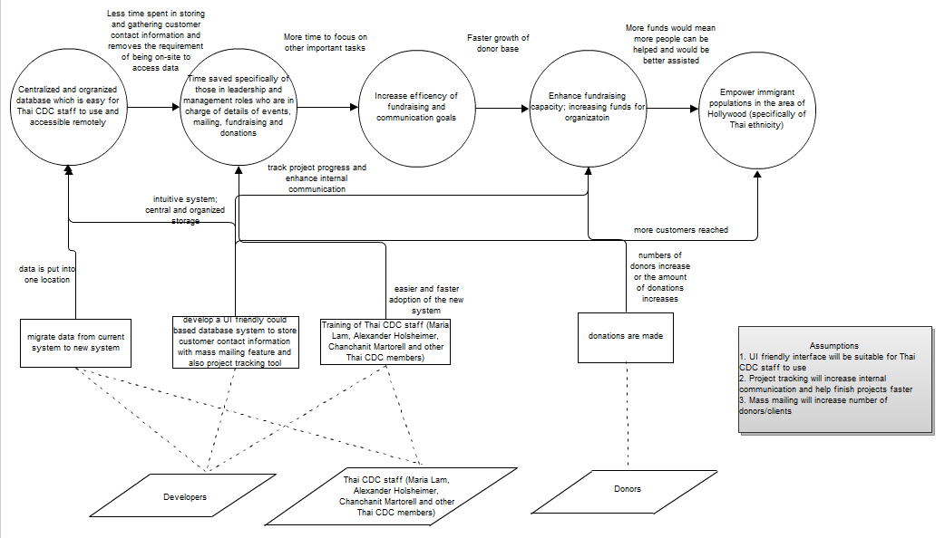
Figure 1: Benefits Chain Diagram of Project Tracking, Mass Mailing, and Central Storing System

2.5 System Boundary and Environment
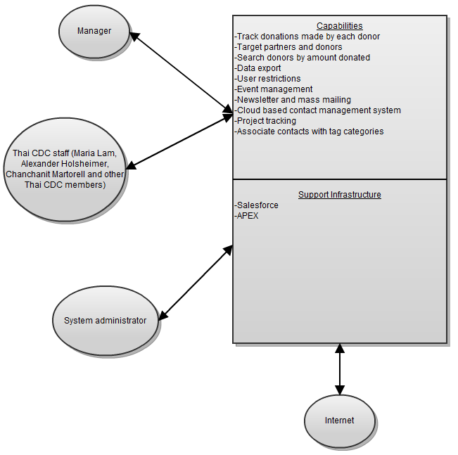
Figure 2: System Boundary and Environment Diagram of Project Tracking, Mass Mailing, and Central Storing System

3. System Transformation

3.1 Information on Current System
3.1.1 Infrastructure
The current system of the client is rudimentary. Most of the data that is used on a day-to-day basis is stored in Microsoft Excel files. The contact information is shared between staff via emails. There exists a Microsoft Access system to store and retrieve data, but it was only used and updated by IT interns.
3.1.2 Artifacts
- Microsoft Access
  - Microsoft Access system that holds client contact information
- Microsoft Excel
  - Microsoft Excel spreadsheets that is maintained separately by each Thai CDC staff member
- Rolodex
  - Rolodex is used by each Thai CDC staff member to maintain their contacts on a daily basis
- Outlook/Google
  - E-mail contact database used individually by each Thai CDC staff member
3.1.3 Current Business Workflow
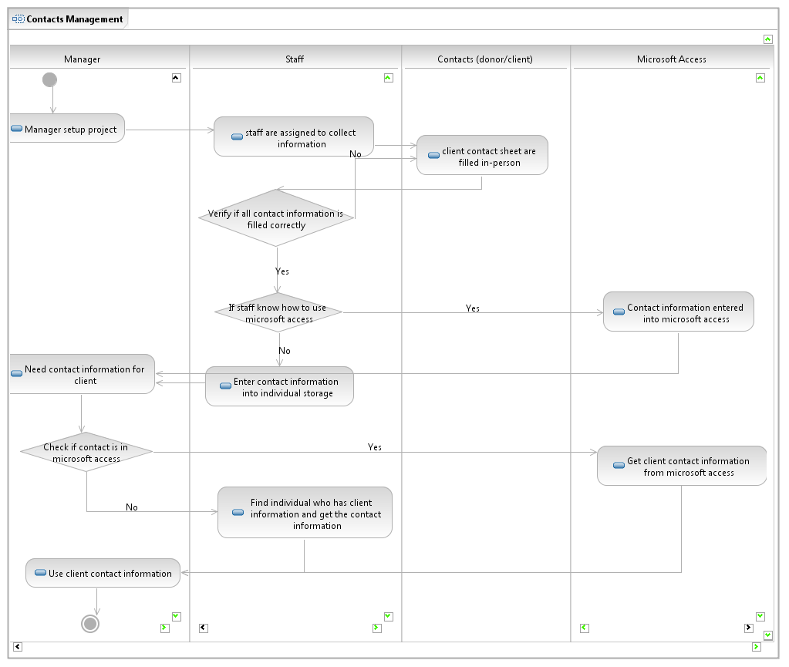
Figure 3: Current Workflow for Contacts Management System

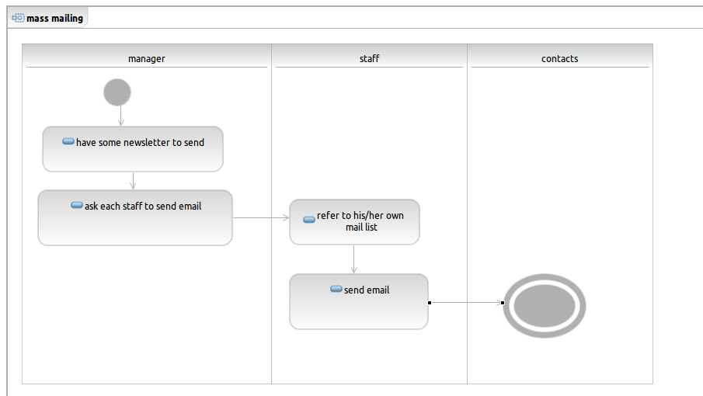
Figure 4: Current Workflow for Mass Mailing

3.2 System Objectives, Constraints and Priorities
3.2.1 Capability Goals
Capability Goals | Priority Level
OC-1 Tracking capabilities: The system should have a way to track donation amounts for each donor | Should have
OC-2 Targeted information: Provide partners and donors information specific to interests including upcoming events, fundraisers, and functions | Must have
OC-3 Search contacts based on donation: Search contacts based on donation history (date donated, amount donated, to what events donated) | Must have
OC-4 Back-up capabilities: Ability to export data so that it can be migrated to a different server | Must have
OC-5 User restrictions: The system should afford different levels of access to users (e.g. managers, interns, supervisors, etc...) | Should have
OC-6 Event management: Efficient control of event management; including RSVP configuration, sending out mail invites, email, etc... | Should have
OC-7 Newsletter and mass mailing: The system will have newsletter/mass-mailing capabilities | Must have
OC-8 Contact management: System with cloud-based Customer Relationship Management (CRM) | Must have
OC-9 Project tracking: Project tracking utility should have all of the fields depicted in Alex's (Thai CDC client) project tracking sketch | Should have
OC-10 Contact tags: Have the ability to add categories and associate contacts to that particular category | Must have

3.2.2 Level of Service Goals
Table 2: Level of Service Goals
Level of Service Goals | Priority Level
LOS-1 Concurrent users: The system will support at least 10 users at the same time (users defined as having different user accounts) | Must have
LOS-2 Size of database: System must be able to support information for at least 4000 contacts | Must have
LOS-3 After-hours access: System must support after-hours access for users except during system outages and system maintenance (default level of access for cloud based CRM) | Must have
LOS-4 Response time: Response time of about 5-10 seconds for complicated tasks | Should have
LOS-5 Security: System will have default level of security for a typical cloud based CRM | Must have

3.2.3 Organizational Goals
OG-1: Decrease time spend collecting client contact information by automating this process
OG-2: Enhance communication with clients and donors by filtering them by interests and other keywords for mass-mailings, event invitations, and donation requests
OG-3: Enhance communication with donors by keeping a history of donation amounts and times
OG-4: Reduction in duplicate emails sent to contacts by storing contacts for entire organization in one location.
OG-5: Better project management by using the project tracking tool and letting everyone in the organization see what is going on.

3.2.4 Constraints
CO-1 Less than $500/year: The system should cost less than $500/year to maintain. Ideally it will be free.
CO-2 Supported by major browsers: The tool should be supported by the following browsers (latest stable release): Firefox, IE, Safari, and Chrome.

3.2.5 Relation to Current System
Table 3: Relation to Current System
Capabilities | Current System | New System
Roles and Responsibilities | Each staff member keeps their contacts stored separately, and is individually responsible for sending mailings to those contacts. There is also one person who is in charge of storing and using the Access database. Project tracking is the responsibility of each individual working on a project. | Contacts are stored in a shared database, so all staff are responsible for updating it. Mass mailings can be sent to all relevant contacts at once rather than each staff member sending mailings separately. Project tracking can now be viewed by everyone in the organization.
User Interactions | Staff use outlook for sending mass mailings and managing contacts. Outlook contacts are not organized in any way. To use group contacts, the staff member must coordinate with the Access database manager in order to get the contact information. Project tracing is done differently for all projects. | Staff with access can easily look up contacts based on interests or other categories and send mass mailings. Projects can be tracked using a standard interface.
Infrastructure | All organizational contacts were stored in an Access database only accessible from one computer. Individuals had their own contacts in Outlook. | All organizational contacts are accessible through a cloud-based system on a thin-client.
Stakeholder Essentials and Amenities | The staff had a way of managing contacts but no way of coordinating among themselves. Project management was done separately for each project. | The staff can use a central database of contacts. They can also track and follow projects.
Future Capabilities | None | More advanced and customized project tracing and contact management can be added.

3.3 Proposed New Operational Concept

3.3.1 Element Relationship Diagram
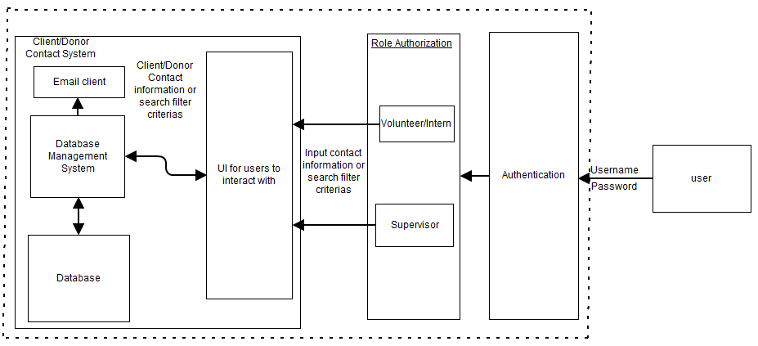
Figure 5: Element Relationship Diagram of Client/Donor Contact System

3.3.2 Business Workflows
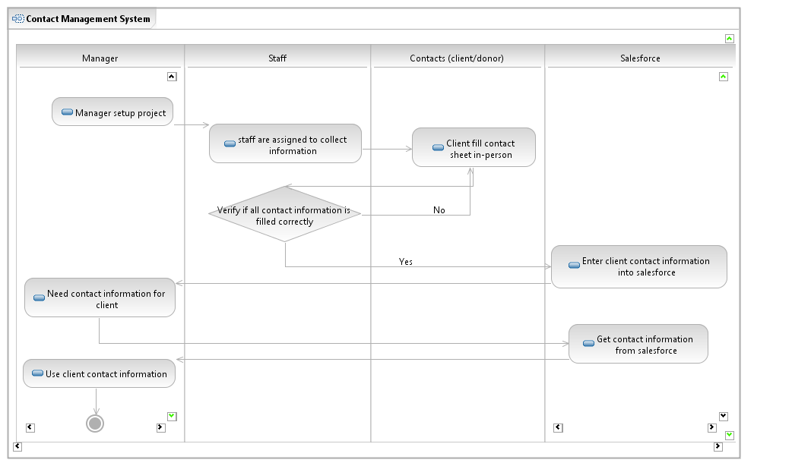
Figure 6: New Workflow for Contacts Management System
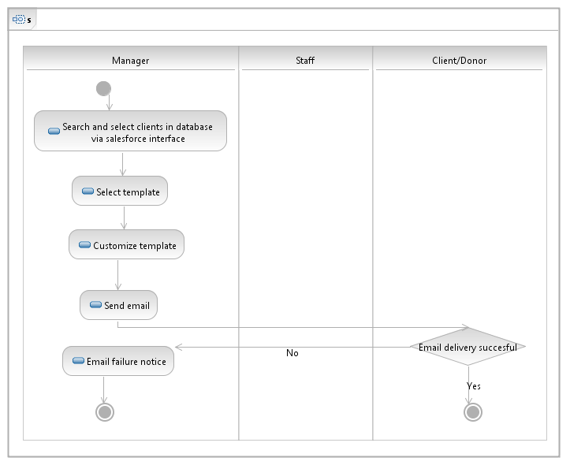
Figure 7: New Workflow for Mass Mailing

3.4 Organizational and Operational Implications

3.4.1 Organizational Transformations
Since the new system will be more organized and easier to use, Microsoft Access will not be needed anymore. One of the goals in developing the new system is that there should be no cost associated in developing and maintaining the system. Therefore the system will be developed so that it is easy enough to be maintained by the current Thai CDC staff. The use of this new system will not affect the current structure of Thai CDC. They will not have to hire or remove anyone due to the usage of the new system. In addition since the data will be available online in a central database, the use of Rolodex and e-mail database will be eliminated. This might reduce the cost to the organization in term of time that the Thai CDC staff takes to store a contact or search for a contact.

3.4.2 Operational Transformations
The new system will make any interactions dealing with client/donor information more efficient leading to a less time wasted by those in leadershipand management roles. The mass mailing feature will allow Thai CDC staff to keep in contact with their customers easily. The client/donor storage system and the mass mailing feature will reduce the wasted time and should help increase the number of clients/donors for Thai CDC. The new system will also make project tracking easier and help increase internal communication about projects.

